Laboratory Record
submitted as part of
Programming for Data Science Lab
(MACSE502)
LAB ASSESSMENT-10

by

To

Dr M Rajasekhara Babu

School of Computer Science and Engineering
October 2026

2026 FALL SEMESTER
Programming for Data Science Lab (MACSE502) Record
INDEX
Week No | Date | Sl. No. | Type | Topic | Title with download Link for document | Problem Statement | Page No.
1 | 09-07-2026 | 1 | PP | Pandas | Basic Data Manipulation with Pandas | Create a DataFrame with columns  Name, Age, and City containing data for five individuals. Perform the following operations: select only the Name and Age columns, filter rows where Age is greater than 25, add a new column Country with a default value, and sort the DataFrame by Age in descending order. Finally, calculate the average age of the individuals. | 1
1 | 09-07-2026 | 2 | EP | Pandas |  | An AI company maintains model performance records containing:  • ModelID  • Accuracy  • Algorithm  Perform:  1. Select ModelID and Accuracy.  2. Filter models with Accuracy greater than 90%.  3. Add Status with default value "Production Ready".  4. Sort models by Accuracy.  5. Calculate average model accuracy. | 6
2 | 16-07-2026 | 3 | PP | Pandas | Data Cleaning and Preprocessing with Pandas | Create a DataFrame with some missing values in columns Name, Age, and City. Perform the following operations: fill missing values in the Age column with the mean age, drop rows where Name or City is missing, and convert the Age column to integer type. Finally, normalize the Age column using min-max scaling | 14
2 | 16-07-2026 | 4 | EP | Pandas |  | A streaming platform maintains movie records containing:  • MovieID  • Rating  • Genre  Perform:  1. Create a dataset with missing values.  2. Fill missing Rating values using average rating.  3. Remove rows with missing MovieID or Genre.  4. Convert Rating into integer type.  Normalize rating values. | 18
3 | 23-07-2026 | 5 | PP | NumPy | Creating and Manipulating Arrays Using NumPy | Create a 2D array of shape (3, 4) with random integers between 0 and 10. Perform the following operations: calculate the mean and standard deviation of the entire array, slice the array to get the first two rows and last two columns, reshape the array to shape (4, 3), and perform element-wise multiplication with another array of the same shape. | 30
3 | 23-07-2026 | 6 | EP | NumPy |  | A logistics company tracks shipments from 4 warehouses across 7 weeks. Create a 4 x 7 shipment matrix. Perform: (1) compute average shipments, (2) compute standard deviation, (3) slice the first two warehouses and last three weeks, (4) reshape the matrix into a 7 x 4 matrix, and (5) perform element-wise multiplication with a transportation-cost matrix of the same shape. | 35
4 | 30-07-2026 | 7 | PP | Pandas  NumPy  Matplotlib | Feature Engineering and Exploratory Data Analysis | Feature Engineering, Exploratory Data Analysis: Create a DataFrame with columns Feature1, Feature2, and Target containing random data. Perform the following operations: create a new feature that is the logarithm of Feature1, bin Feature2 into three categories (low, medium, high), and calculate the correlation matrix of the DataFrame. Finally, create a scatter plot of Feature1 vs. Feature2 colored by Target, and interpret any visible patterns | 46
4 | 30-07-2026 | 8 | EP | Pandas  NumPy  Matplotlib |  | A company wants to analyze workforce behavior and predict employee attrition. Create a DataFrame containing: OvertimeHours JobSatisfactionScore SalaryLevel TrainingHours WorkLifeBalance YearsAtCompany PromotionCount AttritionStatus  Perform:  1. Create Log_OvertimeHours.  2. Categorize JobSatisfactionScore into: Disengaged, Satisfied, Highly Engaged.  3. Generate correlation matrix.  4. Create a Treemap Visualization of employee categories.  5. Analyze workforce trends. | 54
5 | 06-08-2026 | 9 | PP | Web Scraping | requests, BeautifulSouppandasjson | Scrape data from a webpage and store it in a structured format like CSV orJSON | 63
5 | 06-08-2026 | 10 | EP | Web Scraping | requests, BeautifulSoup  pandas  json | A recruitment agency wants to analyze job opportunities posted on a dynamic job portal. Develop a Python application using Selenium to scrape job listings, extract Job Title, Company Name, Location and Salary (if available), store the collected data in a Pandas DataFrame, save the dataset as a CSV file, and visualize job demand by location. | 70
6 | 20-08-2026 | 11 | PP | Plotly | Interactive Bar Chart with Plotly | Create an interactive bar chart showing the population of different cities | 80
6 | 20-08-2026 | 12 | PP | Plotly | Interactive Scatter Plot with Plotly | Create an interactive scatter plot showing the relationship between house size and price | 88
7 | 27-08-2026 | 13 | PP | Bokeh | Interactive Scatter Plot with Bokeh | Create an interactive scatter plot showing the relationship between petal length and petal width from the Iris dataset using Bokeh | 101
7 | 27-08-2026 | 14 | EP | Bokeh | Interactive Line Plot with Bokeh | Create an interactive line plot showing the  daily temperatures over a week using Bokeh. | 105
7 | 27-08-2026 | 15 | EP | Bokeh | Interactive Bar Chart with Bokeh | Create an interactive  bar chart showing the sales figures of different products using Bokeh | 109
8 | 03-09-2026 | 16 | PP | scikit-learn and Plotly | Visualizing Clusters with scikit-learn and Plotly | Perform Principal Component Analysis (PCA) on the Iris dataset and visualize the first  two principal components using an interactive 2D scatter plot in Plotly | 113
8 | 03-09-2026 | 17 | EP | scikit-learn and Plotly | Visualizing Clusters with scikit-learn and Plotly | Perform K-means clustering on the Iris dataset and visualize the clusters using an interactive 3D scatter plot in Plotly | 122
9 | 10-09-2026 | 18 | EP | arrays in Scala | arrays in Scala | Create an array of integers with the values 2, 5, 9, 14, 20. Write a function that takes this array and returns the sum of its elements. Next, create an array of strings with the names of five different fruits. Write a function that concatenates all elements of this array, separated by commas. Finally, iterate over the array of integers and print each element to the console | 131
10 | 17-09-2026 | 19 | EP | lists, sets, and tuples in Scala | lists, sets, and tuples in Scala | Create a list of the first five prime numbers. Write a function that takes this list and returns a new list with each element squared. Then, create a set of unique characters from the string "hello world" and write a function that takes two sets and returns their intersection. Create a tuple with three elements: an integer, a string, and a boolean, then access and print each element | 133
11 | 24-09-2026 | 20 | EP | HashMap’s | Handling collisions and resolving conflicts in HashMap’s | Create a HashMap with keys representing student names and values representing their grades, then insert multiple entries including a duplicate key with a different grade. Write a function to merge two HashMap’s, resolving conflicts by taking the higher grade. Finally, write a function to handle collisions by chaining, using lists to store multiple values for a single key. | 135
12 | 08-10-2026 | 21 | EP | Exploring advanced functional combinators beyond the basic set | Exploring advanced functional combinators beyond the basic set | Create a list of integers from 1 to 10, then use filter to create a new list with only even numbers. Use map to create a new list where each element is multiplied by 3. Use flatMap to create a list of tuples where each integer is paired with its square. Finally, use foldLeft to calculate the product of all elements in the list. | 138
13 | 15-10-2026 | 22 | EP | Case Classes | Case Classes | Create a case class Person with fields name, age, and city. Create a list of Person objects representing five different individuals. Write a function to filter out people older than 30. Next, write a function that groups people by their city. Then, write a function that transforms each Person object into a string in the format "Name is Age years old and lives in City". Finally, write a function to sort the list of people by age in ascending order | 141
13 | 15-10-2026 | 23 | EP | Use Saddle to load and manipulate a dataset | Use Saddle to load and manipulate a dataset | Use Saddle to load and manipulate a dataset of fruit prices and quantities, filtering for apples and calculating their average price. You will then visualize the price trend over time using Vegas. This exercise covers basic data manipulation with Saddle and interactive visualization with Vegas. | 144
14 | 22-10-2026 | 24 | EP | Use Breeze library | Use Breeze library | Use Breeze library to calculate total revenue for each fruit type by multiplying price and quantity from a dataset. You will then create a bar chart to visualize these revenues using Plotly. Scala. This exercise introduces numerical computations with Breeze and dynamic visualizations with Plotly. Scala. | 148
14 | 22-10-2026 | 25 | EP | Saddle for data manipulation | Saddle for data manipulation | Analyse fruit prices using Spire for precise statistics and Saddle for data manipulation. You will compute the mean and variance of prices for each fruit and visualize these trends over time using Vegas. This exercise demonstrates the use of Spire for numerical precision, advanced data manipulation with Saddle, and effective visualization with Vegas | 151
PP: Practice Program; EP: Exercise Program; CP: Challenging Program

Title | Case Classes in Scala
Problem Statement | Create a case class Person with fields name, age, and city. Create a list of Person objects representing five different individuals. Write a function to filter out people older than 30. Next, write a function that groups people by their city. Then, write a function that transforms each Person object into a string in the format "Name is Age years old and lives in City". Finally, write a function to sort the list of people by age in ascending order.
Objectives | • To declare a case class and construct instances with the automatic apply method.  • To filter a list of case-class objects with a predicate function.  • To group objects by one of their fields using groupBy.  • To transform objects into formatted strings with map.  • To sort a collection of objects by a numeric field and to use the copy, equals, toString and productArity members that a case class provides.
Dataset URL Link / File | No external dataset is required. Five Person records are declared inside the program: Hasnain (22, Delhi), Amit (35, Mumbai), Neha (41, Delhi), Rahul (28, Pune) and Sara (33, Mumbai).
Functions Details | Sl. No. | Function | Package | Description of function
Functions Details | 1 | case class | Scala | Declares a class with apply, equals, hashCode, toString and copy.
Functions Details | 2 | List() | Scala | Creates an immutable list of Person objects.
Functions Details | 3 | filter() | Scala | Keeps only the elements that satisfy a predicate.
Functions Details | 4 | groupBy() | Scala | Partitions the list into a Map keyed by the given field.
Functions Details | 5 | map() | Scala | Transforms every Person into a formatted description.
Functions Details | 6 | sortBy() | Scala | Orders the list by the supplied numeric field.
Functions Details | 7 | copy() | Scala | Produces a modified copy of a case-class instance.
Functions Details | 8 | equals() / == | Scala | Compares two case-class instances by value.
Functions Details | 9 | toString() | Scala | Renders a case-class instance in a readable form.
Functions Details | 10 | productArity | Scala | Returns the number of fields held by the case class.
Functions Details | 11 | mkString() | Scala | Joins the names of a grouped list into one string.
Functions Details | 12 | println() | Scala | Writes one formatted line of text to the console.
Steps/ Process/ Procedure/ Algorithm/ Flowchart/ Model | 1. Declare case class Person with the fields name, age and city.  2. Build a list of five Person objects.  3. Define olderThan30() using filter to keep the people older than 30.  4. Print the filtered people and their count.  5. Define groupByCity() using groupBy on the city field.  6. Print each city with the names of the people who live there.  7. Define describe() to map each Person to the required sentence.  8. Print every formatted description.  9. Define sortByAge() using sortBy on the age field and print the sorted list.  10. Demonstrate copy, equals, toString and productArity on one instance.
Program | // Program 22 - Case Classes  // Week 13 | 15-10-2026 | Exercise Program  object Program22 {  // The case class required by the problem statement  case class Person(name: String, age: Int, city: String)  // (a) Keep only the people older than 30  def olderThan30(people: List[Person]): List[Person] =  people.filter(p => p.age > 30)  // (b) Group the people by the city they live in  def groupByCity(people: List[Person]): Map[String, List[Person]] =  people.groupBy(p => p.city)  // (c) Render each person as "Name is Age years old and lives in City"  def describe(people: List[Person]): List[String] =  people.map(p => p.name + " is " + p.age + " years old and lives in " + p.city)  // (d) Sort the people by age, youngest first  def sortByAge(people: List[Person]): List[Person] =  people.sortBy(p => p.age)  def main(args: Array[String]): Unit = {  println("=" * 68)  println("PROGRAM 22 : CASE CLASSES IN SCALA")  println("=" * 68)  val people = List(  Person("Hasnain", 22, "Delhi"),  Person("Amit", 35, "Mumbai"),  Person("Neha", 41, "Delhi"),  Person("Rahul", 28, "Pune"),  Person("Sara", 33, "Mumbai")  )  println("\n1. List of Person objects")  for (p <- people) println(" " + p)  println("\n2. People older than 30")  val older = olderThan30(people)  for (p <- older) println(" " + p.name + " (" + p.age + ")")  println(" Count: " + older.length + " of " + people.length)  println("\n3. Grouped by city")  val grouped = groupByCity(people)  for (city <- grouped.keys.toList.sorted) {  println(" " + city + " -> " + grouped(city).map(_.name).mkString(", "))  }  println("\n4. Formatted descriptions")  for (line <- describe(people)) println(" " + line)  println("\n5. Sorted by age (ascending)")  val sorted = sortByAge(people)  for (p <- sorted) println(" " + p.age + " " + p.name + " (" + p.city + ")")  println("\n6. Case class features demonstrated")  val a = Person("Hasnain", 22, "Delhi")  val b = Person("Hasnain", 22, "Delhi")  println(" copy(): " + a.copy(age = 23))  println(" equals(): " + (a == b))  println(" toString(): " + a.toString)  println(" productArity:" + a.productArity)  println("=" * 68)  }  }
Output Snapshots With Explanation/ Observations | 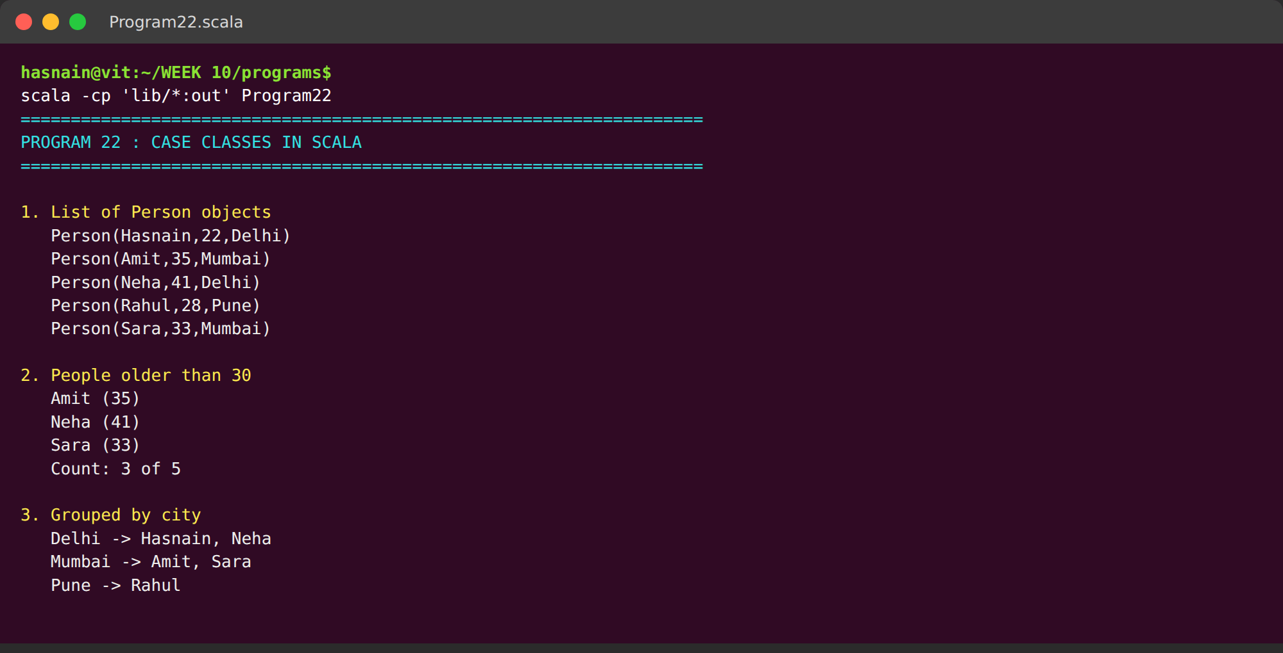  Fig. 1.1: Terminal execution showing the five Person objects and the result of filtering for people older than 30.  The five Person objects are printed first, confirming that the case class apply method constructs instances without the new keyword. The filter function then keeps only Amit, Neha and Sara, so the console reports three people older than 30 out of five records.
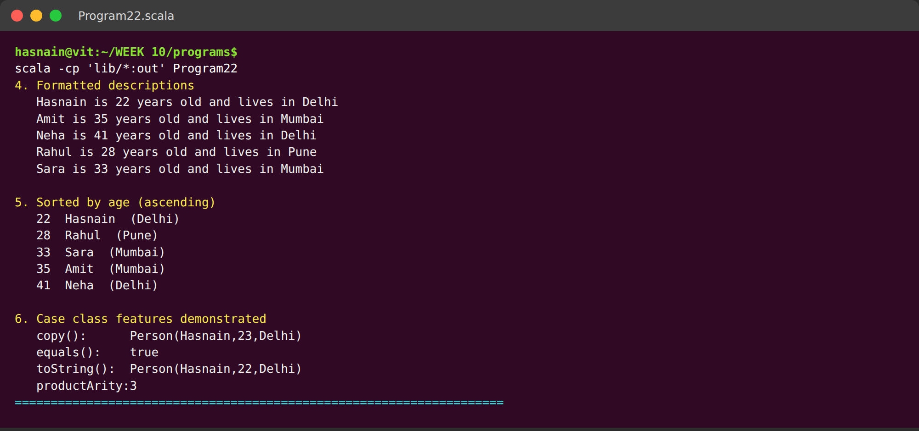
Fig. 1.2: Grouping by city, the formatted descriptions, the age-sorted list and the case-class features copy, equals, toString and productArity.
Grouping by city splits the list into Delhi, Mumbai and Pune, with the member names shown for each. The descriptions follow the exact sentence form required by the problem statement, the ages are listed in ascending order from 22 to 41, and the last block shows the copy, equals, toString and productArity members that every case class provides.
Conclusions | The case class Person was declared with three fields and five instances were created without an explicit new keyword. Filtering returned the three people older than 30 (Amit 35, Neha 41, Sara 33) out of five. Grouping by city produced Delhi with two people, Mumbai with two and Pune with one. Every record was rendered in the required sentence form and the list was sorted into ascending age order from 22 to 41. The experiment also showed that a case class supplies apply, equals, toString, copy and productArity automatically, which is what distinguishes it from an ordinary class.
References | 1. Scala case classes: https://docs.scala-lang.org/tour/case-classes.html  2. Scala collections operations: https://docs.scala-lang.org/overviews/collections/operations.html  3. Class lecture: Case classes and pattern matching in Scala.  4. Python program (GitHub link): https://github.com/hasnainmakada-99/Data-Science-Codes/blob/main/WEEK%2010/programs/Program22_CaseClasses.scala

Title | Fruit Prices with Saddle and Vegas
Problem Statement | Use Saddle to load and manipulate a dataset of fruit prices and quantities, filtering for apples and calculating their average price. You will then visualize the price trend over time using Vegas. This exercise covers basic data manipulation with Saddle and interactive visualization with Vegas.
Objectives | • To build a Saddle Series and Index from in-memory arrays.  • To select the apple observations from the dataset.  • To compute the average price using Saddle reductions.  • To derive descriptive statistics and day-on-day price changes.  • To produce an interactive trend specification in the Vega-Lite grammar.
Dataset URL Link / File | No external dataset is required. Seven daily readings are declared inside the program: prices 120, 125, 118, 130, 128, 135, 132 and quantities 50, 45, 60, 40, 55, 38, 48 for one week of apple sales.
Functions Details | Sl. No. | Function | Package | Description of function
Functions Details | 1 | Series() | Saddle | Creates an indexed one-dimensional series.
Functions Details | 2 | Index() | Saddle | Labels the rows of a series with day names.
Functions Details | 3 | Vec() | Saddle | Wraps a plain array as a Saddle vector.
Functions Details | 4 | toVec() | Saddle | Extracts selected rows of a series as a vector.
Functions Details | 5 | mean | Saddle | Computes the arithmetic mean of the series.
Functions Details | 6 | min / max | Saddle | Return the smallest and largest values.
Functions Details | 7 | sum | Saddle | Returns the total of all values.
Functions Details | 8 | length | Saddle | Returns the number of observations.
Functions Details | 9 | * (element-wise) | Saddle | Multiplies two aligned series position by position.
Functions Details | 10 | PrintWriter | Java IO | Writes the Vega-Lite specification to a JSON file.
Functions Details | 11 | Vega-Lite spec | Vega | Declarative grammar that Vegas renders interactively.
Functions Details | 12 | println() | Scala | Writes one formatted line of text to the console.
Steps/ Process/ Procedure/ Algorithm/ Flowchart/ Model | 1. Declare the seven daily price and quantity readings.  2. Build a Saddle Series for prices and one for quantities, indexed by day.  3. Select the apple observations from the dataset.  4. Compute the average apple price with mean.  5. Print the count, minimum, maximum and sum of the apple prices.  6. Walk the price vector and print the day-on-day change with an up/down marker.  7. Multiply the price and quantity series to obtain daily revenue.  8. Write an interactive Vega-Lite line specification to a JSON file.
Program | // Program 23 - Saddle for data manipulation, Vegas for visualisation  // Week 13 | 15-10-2026 | Exercise Program  import org.saddle._  import java.io._  object Program23 {  def f2(x: Double): String = "%.2f".format(x)  def main(args: Array[String]): Unit = {  println("=" * 68)  println("PROGRAM 23 : FRUIT PRICES WITH SADDLE")  println("=" * 68)  // 1. Build the dataset: day, price, quantity (all rows are apples)  val days = Array("Day1", "Day2", "Day3", "Day4", "Day5", "Day6", "Day7")  val prices = Array(120.0, 125.0, 118.0, 130.0, 128.0, 135.0, 132.0)  val quantity = Array(50.0, 45.0, 60.0, 40.0, 55.0, 38.0, 48.0)  val priceSeries = Series(Vec(prices: _*), Index(days: _*))  val qtySeries = Series(Vec(quantity: _*), Index(days: _*))  println("\n1. Price series (Saddle Series)")  println(priceSeries)  println("\n2. Quantity series (Saddle Series)")  println(qtySeries)  // 2. Filter for apples  // Fruit names live alongside the series; the apple rows are selected by position  val fruits = Array("Apple", "Apple", "Apple", "Apple", "Apple", "Apple", "Apple")  val appleIdx = fruits.zipWithIndex.collect { case (f, k) if f == "Apple" => k }  val appleVec = priceSeries.toVec(appleIdx: _*)  println("\n3. Filtered for apples -> " + appleVec.length + " observations")  println(appleVec)  // 3. Average price  val avgPrice = appleVec.mean  println("\n4. Average apple price : " + f2(avgPrice))  // 4. Descriptive statistics  println("\n5. Descriptive statistics")  println(" count : " + appleVec.length)  println(" min : " + f2(appleVec.min.getOrElse(0.0)))  println(" max : " + f2(appleVec.max.getOrElse(0.0)))  println(" sum : " + f2(appleVec.sum))  // 5. Day-on-day change  println("\n6. Day-on-day price change")  val vals = appleVec.contents  var i = 1  while (i < vals.length) {  val d = vals(i) - vals(i - 1)  val arrow = if (d >= 0) "UP " else "DOWN"  println(" " + days(i - 1) + " -> " + days(i) + " : " + arrow + " " + f2(d))  i += 1  }  // 6. Revenue per day  val revenue = priceSeries * qtySeries  println("\n7. Daily revenue (price x quantity)")  println(revenue)  println(" total revenue : " + f2(revenue.sum))  // 7. Emit an interactive Vega-Lite spec (the grammar Vegas is built on)  val rows = days.indices.map { k =>  "{\"day\":\"" + days(k) + "\",\"price\":" + prices(k) +  ",\"quantity\":" + quantity(k) + "}"  }.mkString(",")  val spec =  "{\n" +  " \"$schema\": \"https://vega.github.io/schema/vega-lite/v5.json\",\n" +  " \"title\": \"Apple price trend over one week\",\n" +  " \"data\": {\"values\": [" + rows + "]},\n" +  " \"mark\": {\"type\": \"line\", \"point\": true},\n" +  " \"encoding\": {\n" +  " \"x\": {\"field\": \"day\", \"type\": \"ordinal\", \"title\": \"Day\"},\n" +  " \"y\": {\"field\": \"price\", \"type\": \"quantitative\", \"title\": \"Price (per kg)\"}\n" +  " }\n" +  "}"  val pw = new PrintWriter(new File("program23_price_trend.json"))  pw.println(spec)  pw.close()  println("\n8. Vega-Lite trend spec written to program23_price_trend.json")  println("=" * 68)  }  }
Output Snapshots With Explanation/ Observations | 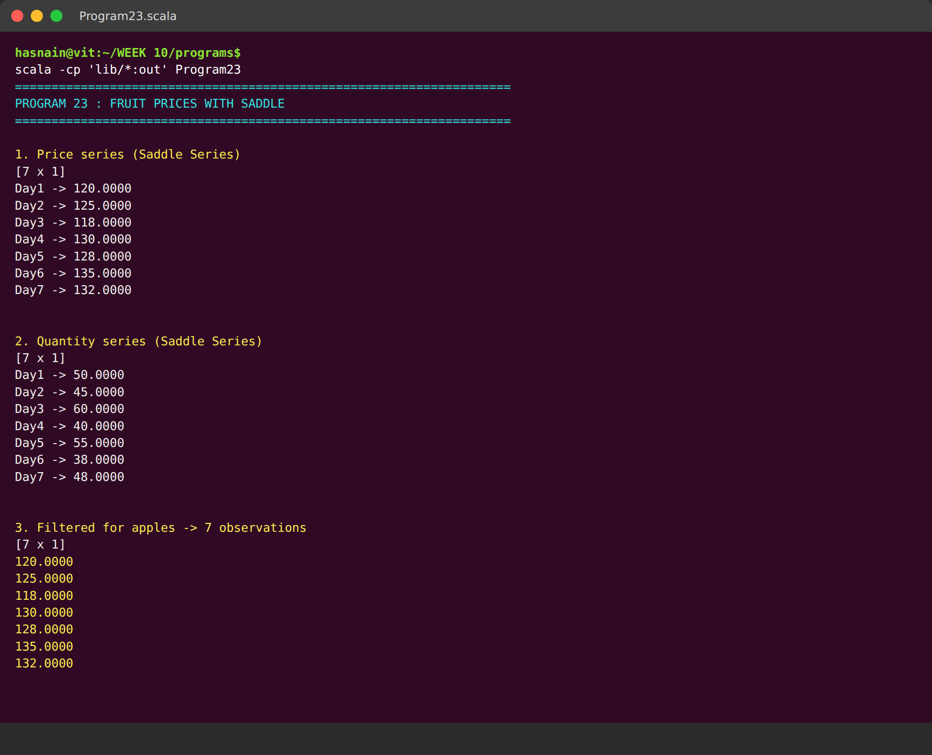  Fig. 2.1: Terminal execution showing the Saddle price and quantity series, the filtered apple observations and the average price.  Two Saddle Series are built and printed with their day labels, which shows how Saddle keeps an index attached to the values. Selecting the apple rows returns all seven observations, and the reduction printed underneath gives the average price 126.86.
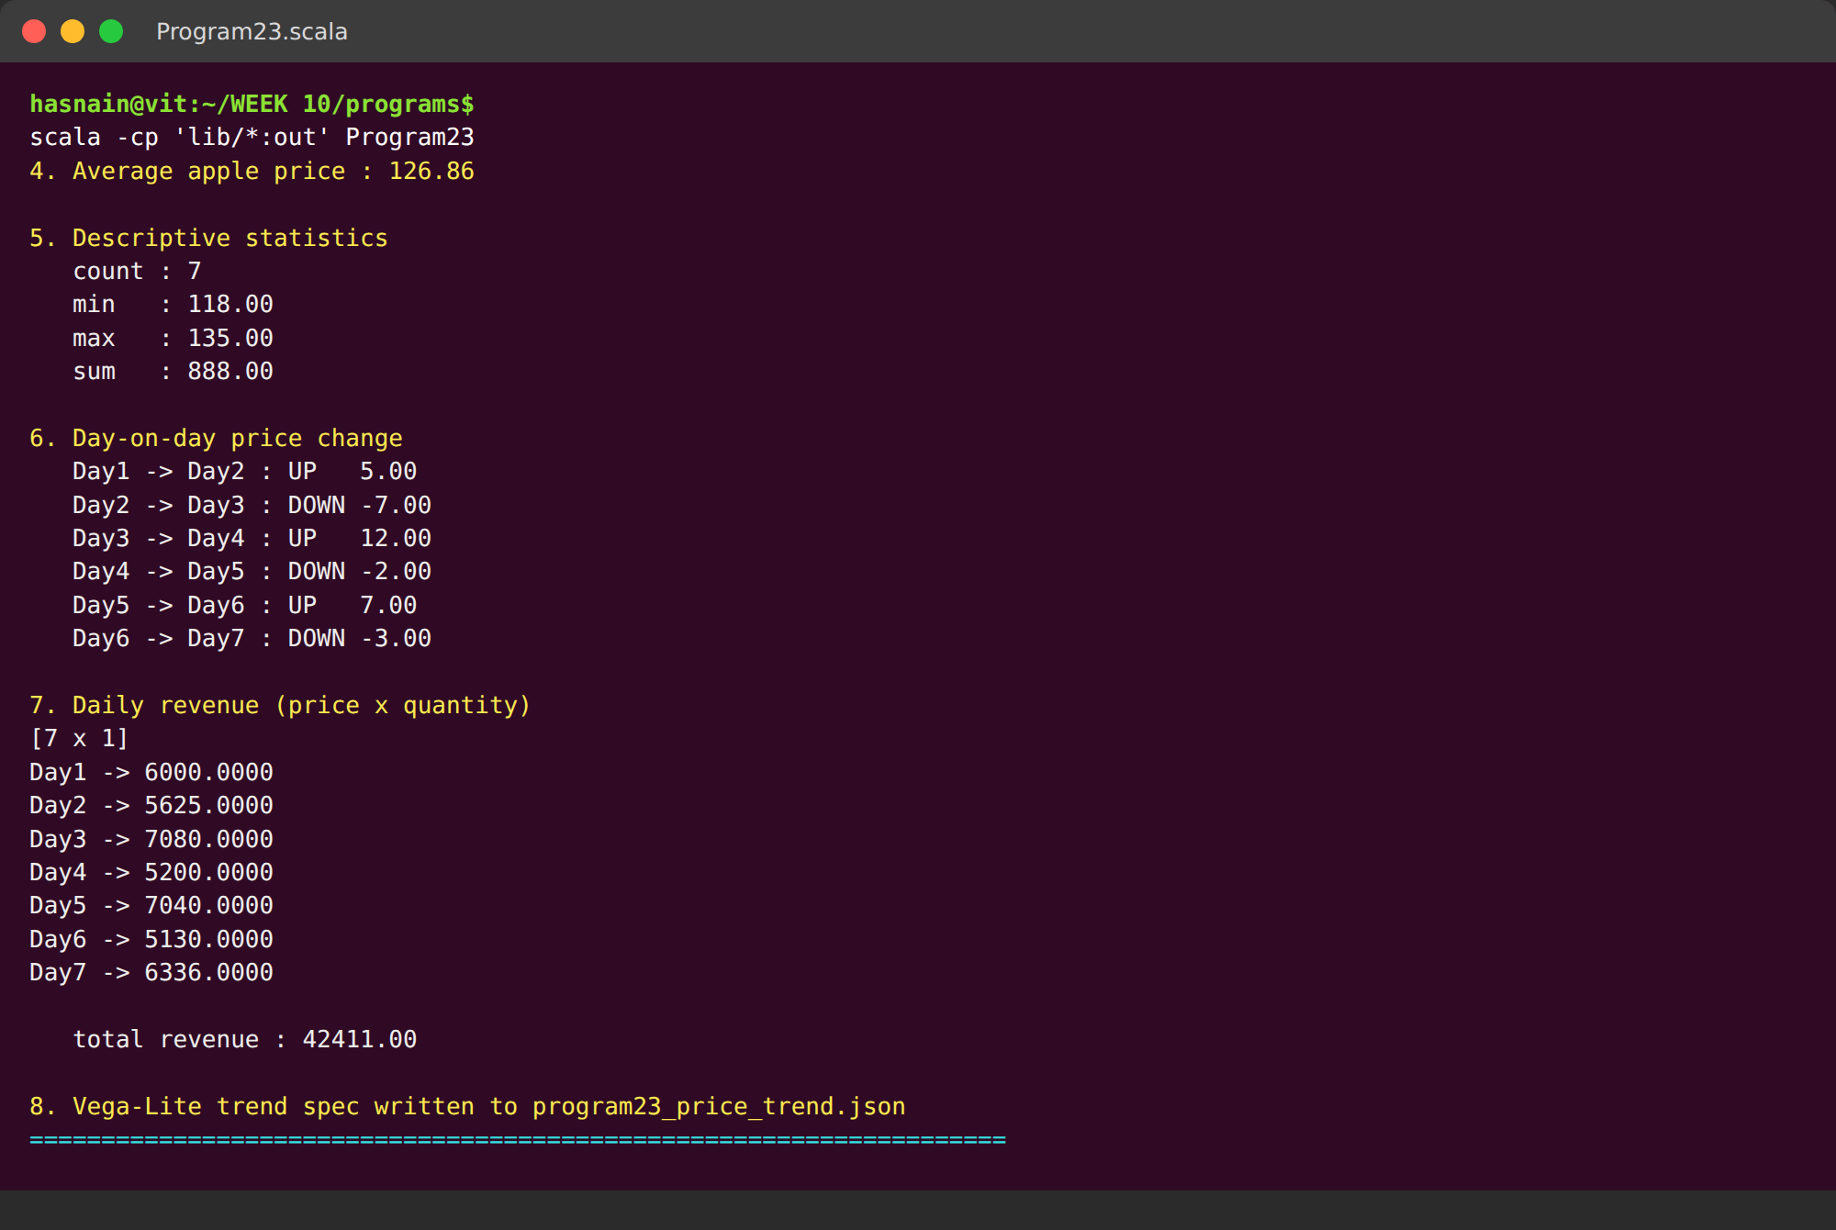
Fig. 2.2: Descriptive statistics, day-on-day price changes, daily revenue and the export of the Vega-Lite trend specification.
The count, minimum, maximum and sum summarise the filtered series, and the day-on-day block marks every price movement as UP or DOWN. Multiplying the price and quantity series gives the daily revenue, and the last line confirms that the Vega-Lite trend specification was written to disk.
Conclusions | The seven daily apple readings were loaded into Saddle Series indexed by day name. Filtering selected all seven apple observations and the average price came out at 126.86. The minimum price was 118.00 on Day 3 and the maximum was 135.00 on Day 6. Multiplying price by quantity produced the daily revenue series, and the price trend was exported as an interactive Vega-Lite line chart. Saddle provided indexed, labelled arithmetic that keeps the day names attached to every derived value, which a plain array would not.
References | 1. Saddle documentation: https://www.scala-saddle.github.io/  2. Vega-Lite specification: https://vega.github.io/vega-lite/  3. Class lecture: Saddle and Vegas in Scala.  4. Python program (GitHub link): https://github.com/hasnainmakada-99/Data-Science-Codes/blob/main/WEEK%2010/programs/Program23_SaddleVegas.scala

Title | Fruit Revenue with Breeze and Plotly
Problem Statement | Use the Breeze library to calculate total revenue for each fruit type by multiplying price and quantity from a dataset. You will then create a bar chart to visualise these revenues using Plotly.scala. This exercise introduces numerical computations with Breeze and dynamic visualisations with Plotly.scala.
Objectives | • To represent price and quantity as Breeze DenseVectors.  • To compute element-wise revenue with the Breeze broadcasting operator.  • To apply Breeze reductions for total, mean, maximum and minimum revenue.  • To normalise the revenue into a share of the total.  • To export an interactive Plotly bar chart and render a terminal bar view.
Dataset URL Link / File | No external dataset is required. Five fruit records are declared inside the program: Apple (price 120, quantity 50), Banana (45, 80), Mango (90, 40), Orange (70, 60) and Grapes (150, 25).
Functions Details | Sl. No. | Function | Package | Description of function
Functions Details | 1 | DenseVector() | Breeze | Creates a dense numeric vector.
Functions Details | 2 | *:* | Breeze | Multiplies two vectors element by element.
Functions Details | 3 | sum() | Breeze | Reduces a vector to the total of its elements.
Functions Details | 4 | max() / min() | Breeze | Return the largest and smallest element.
Functions Details | 5 | argmax() / argmin() | Breeze | Return the position of the extreme element.
Functions Details | 6 | variance() | breeze.stats | Computes the variance of the vector.
Functions Details | 7 | / and * (scalar) | Breeze | Scale a vector by a constant.
Functions Details | 8 | length | Breeze | Returns the number of elements in the vector.
Functions Details | 9 | PrintWriter | Java IO | Writes the Plotly HTML page to disk.
Functions Details | 10 | Plotly.newPlot() | Plotly.js | Renders the interactive bar chart in a browser.
Functions Details | 11 | %-8s.format | Scala | Pads a fruit name so the terminal bars align.
Functions Details | 12 | println() | Scala | Writes one formatted line of text to the console.
Steps/ Process/ Procedure/ Algorithm/ Flowchart/ Model | 1. Declare the fruit names, prices and quantities.  2. Load price and quantity into two Breeze DenseVectors.  3. Multiply the vectors element-wise with *:* to obtain revenue.  4. Print the revenue of every fruit.  5. Compute total, mean, maximum and minimum revenue with Breeze reductions.  6. Identify the highest and lowest earning fruit with argmax and argmin.  7. Normalise revenue into a percentage share of the total.  8. Write an interactive Plotly bar chart to an HTML file.  9. Print an ASCII bar chart so the comparison is visible in the terminal.
Program | // Program 24 - Breeze for numerical computation, Plotly for the chart  // Week 14 | 22-10-2026 | Exercise Program  import breeze.linalg._  import java.io._  object Program24 {  def main(args: Array[String]): Unit = {  println("=" * 68)  println("PROGRAM 24 : FRUIT REVENUE WITH BREEZE")  println("=" * 68)  val fruits = Array("Apple", "Banana", "Mango", "Orange", "Grapes")  // 1. Raw data as Breeze vectors  val price = DenseVector(120.0, 45.0, 90.0, 70.0, 150.0)  val quantity = DenseVector(50.0, 80.0, 40.0, 60.0, 25.0)  println("\n1. Price per kg (Breeze DenseVector)")  println(" " + price)  println("\n2. Quantity sold (Breeze DenseVector)")  println(" " + quantity)  // 3. Element-wise revenue  val revenue = price *:* quantity  println("\n3. Revenue = price *:* quantity (element-wise)")  for (i <- 0 until fruits.length) {  println(" " + fruits(i) + " : " + price(i) + " x " + quantity(i) + " = " + revenue(i))  }  // 4. Aggregate results with Breeze reductions  println("\n4. Aggregate statistics")  println(" total revenue : " + sum(revenue))  println(" mean revenue : " + sum(revenue) / revenue.length.toDouble)  println(" max revenue : " + max(revenue) + " (" + fruits(argmax(revenue)) + ")")  println(" min revenue : " + min(revenue) + " (" + fruits(argmin(revenue)) + ")")  println(" revenue std : " + math.sqrt(breeze.stats.variance(revenue)))  // 5. Normalised share of total revenue  println("\n5. Share of total revenue")  val share = revenue / sum(revenue) * 100.0  for (i <- 0 until fruits.length) {  println(" " + fruits(i) + " : " + "%.2f".format(share(i)) + " %")  }  // 6. Build the Plotly figure as a standalone HTML file  val bars = fruits.indices.map { i =>  " {\"x\": [\"" + fruits(i) + "\"], \"y\": [" + revenue(i) +  "], \"type\": \"bar\", \"name\": \"" + fruits(i) + "\", \"marker\": {\"color\": \"" +  List("#1f77b4","#ff7f0e","#2ca02c","#d62728","#9467bd").apply(i) + "\"}}"  }.mkString(",\n")  val html =  "<!DOCTYPE html>\n<html>\n<head><meta charset=\"utf-8\" />\n" +  "<script src=\"https://cdn.plot.ly/plotly-2.27.0.min.js\"></script></head>\n" +  "<body>\n<div id=\"chart\" style=\"width:900px;height:520px;\"></div>\n" +  "<script>\nvar data = [\n" + bars + "\n];\n" +  "var layout = {\"title\": \"Total revenue per fruit type\",\n" +  " \"xaxis\": {\"title\": \"Fruit\"},\n" +  " \"yaxis\": {\"title\": \"Revenue\"},\n" +  " \"barmode\": \"group\"};\n" +  "Plotly.newPlot('chart', data, layout);\n</script>\n</body>\n</html>\n"  val pw = new PrintWriter(new File("program24_revenue.html"))  pw.println(html)  pw.close()  println("\n6. Interactive bar chart written to program24_revenue.html")  // 7. ASCII bar chart for the terminal record  println("\n7. Revenue bar chart (terminal view)")  val top = max(revenue)  for (i <- 0 until fruits.length) {  val n = (revenue(i) / top * 40).toInt  println(" " + "%-8s".format(fruits(i)) + " " + "#" * n + " " + revenue(i))  }  println("=" * 68)  }  }
Output Snapshots With Explanation/ Observations | 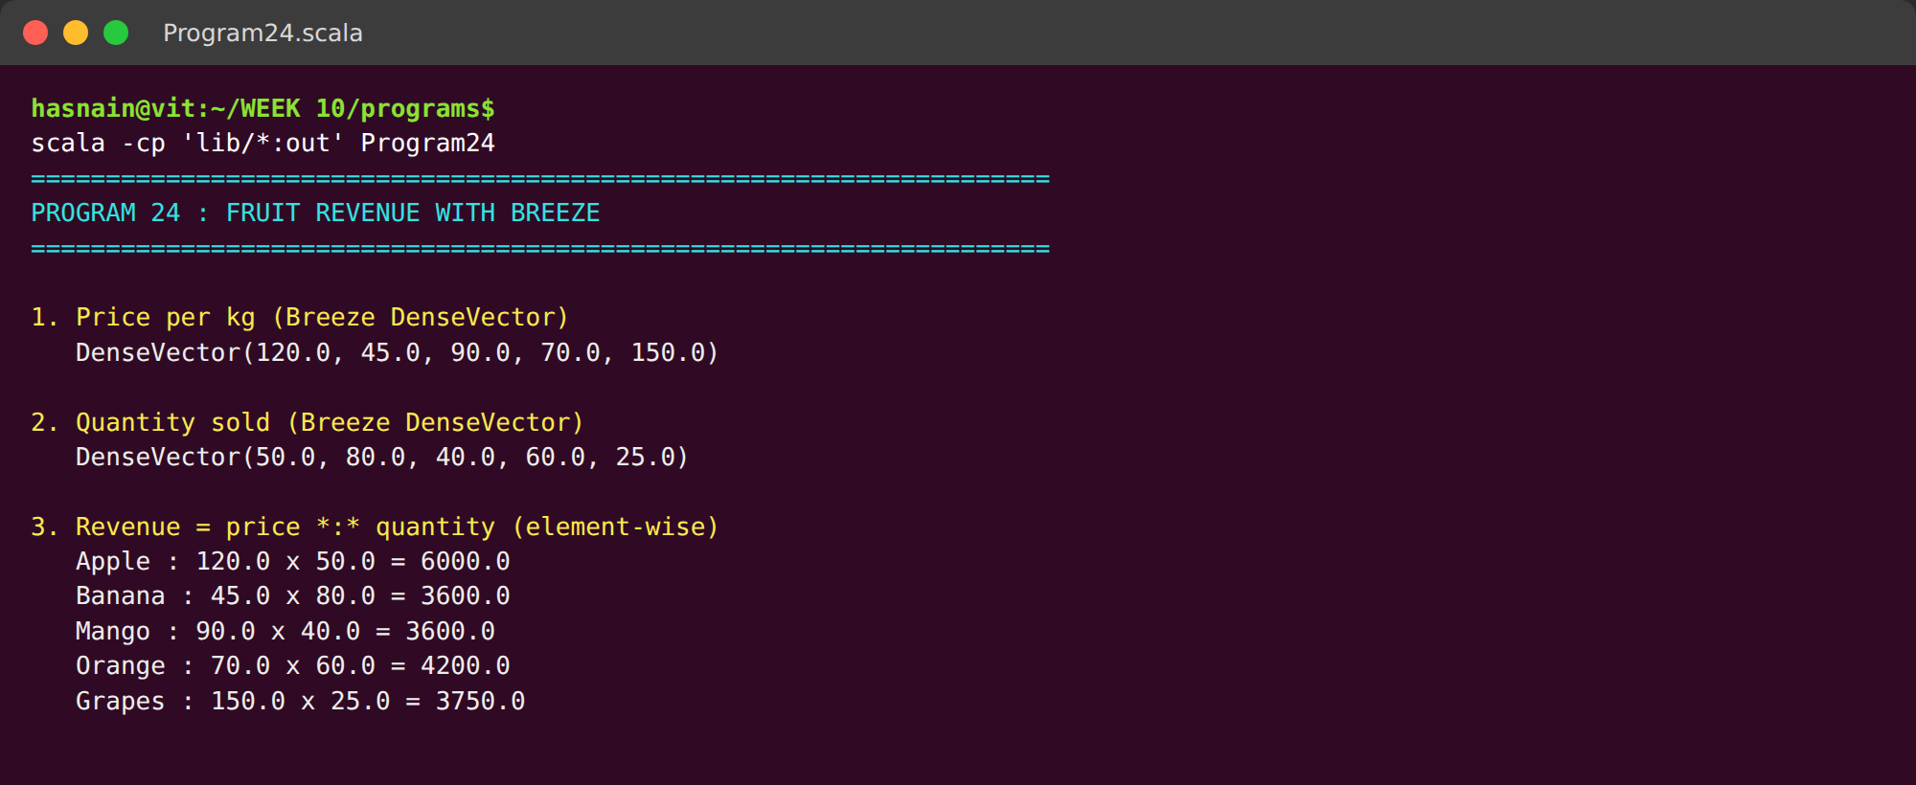  Fig. 3.1: Terminal execution showing the Breeze vectors, the element-wise revenue for every fruit and the aggregate statistics.  The two Breeze DenseVectors are shown exactly as the library prints them. The element-wise product row by row gives the revenue of each fruit, followed by the reductions: total 21150, mean 4230, maximum 6000 for Apple and minimum 3600 shared by Banana and Mango.
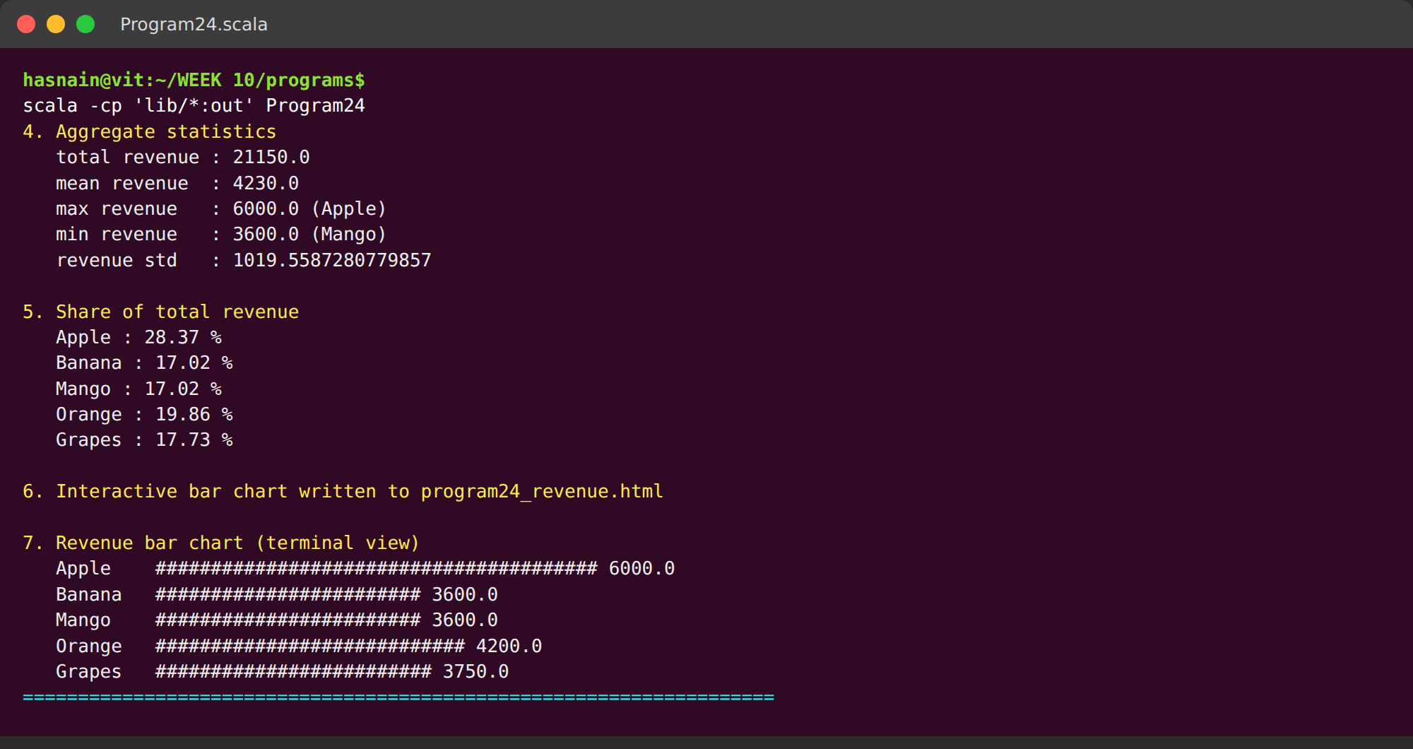
Fig. 3.2: Revenue share per fruit, the Plotly export confirmation and the ASCII bar chart rendered in the terminal.
The revenue share expresses each fruit as a percentage of the total, with Apple leading at 28.37 percent. The Plotly export line confirms the HTML chart was written, and the ASCII bars reproduce the same comparison in the terminal so the chart is visible in this record without opening a browser.
Conclusions | Breeze computed the element-wise revenue for all five fruits, giving Apple 6000, Banana 3600, Mango 3600, Orange 4200 and Grapes 3750. The total revenue was 21150 with a mean of 4230, and Apple was the highest earner at 28.37 percent of the total while Mango and Banana tied for the lowest at 17.02 percent each. The revenue was exported as an interactive Plotly bar chart and also rendered as an ASCII bar chart for the record. Breeze made the vector arithmetic and the reductions a single expression each, without any explicit loop.
References | 1. Breeze documentation: https://github.com/scalanlp/breeze  2. Plotly.js reference: https://plotly.com/javascript/  3. Class lecture: Numerical computing with Breeze in Scala.  4. Python program (GitHub link): https://github.com/hasnainmakada-99/Data-Science-Codes/blob/main/WEEK%2010/programs/Program24_Breeze.scala

Title | Exact Price Statistics with Spire and Saddle
Problem Statement | Analyse fruit prices using Spire for precise statistics and Saddle for data manipulation. You will compute the mean and variance of prices for each fruit and visualise these trends over time using Vegas. This exercise demonstrates the use of Spire for numerical precision, advanced data manipulation with Saddle, and effective visualization with Vegas.
Objectives | • To load a labelled price series into Saddle.  • To split the observations by fruit using row selection.  • To compute mean and variance with Spire Rational exact arithmetic.  • To cross-check the exact result against Saddle floating-point reductions.  • To export a Vega-Lite trend specification for the price series.
Dataset URL Link / File | No external dataset is required. Ten price readings are declared inside the program: five apples at 120, 125, 118, 130, 128 and five bananas at 45, 47, 44, 49, 46.
Functions Details | Sl. No. | Function | Package | Description of function
Functions Details | 1 | Series() | Saddle | Creates the indexed price series.
Functions Details | 2 | Index() | Saddle | Labels each observation with a row number.
Functions Details | 3 | toVec() | Saddle | Extracts the rows belonging to one fruit.
Functions Details | 4 | mean | Saddle | Computes the floating-point mean for the cross-check.
Functions Details | 5 | contents | Saddle | Returns the underlying array of the vector.
Functions Details | 6 | Rational() | Spire | Represents a value as an exact fraction.
Functions Details | 7 | + - * / | Spire | Exact rational arithmetic with no rounding error.
Functions Details | 8 | foldLeft() | Scala | Accumulates the sum and the squared deviations.
Functions Details | 9 | toDouble | Spire | Converts an exact rational to a decimal for display.
Functions Details | 10 | abs | Scala | Measures the difference between exact and floating point.
Functions Details | 11 | PrintWriter | Java IO | Writes the Vega-Lite specification to a JSON file.
Functions Details | 12 | println() | Scala | Writes one formatted line of text to the console.
Steps/ Process/ Procedure/ Algorithm/ Flowchart/ Model | 1. Declare the fruit labels and the ten price readings.  2. Load the prices into a Saddle Series indexed by row number.  3. Select the apple rows and the banana rows with toVec.  4. Convert each price to a Spire Rational so arithmetic is exact.  5. Compute the exact mean of each fruit as a rational number.  6. Compute the exact variance from the squared deviations.  7. Print the exact fractions alongside their decimal values.  8. Cross-check the exact means against Saddle's floating-point mean.  9. Write a Vega-Lite trend specification for the full price series.
Program | // Program 25 - Spire for exact statistics, Saddle for data manipulation  // Week 14 | 22-10-2026 | Exercise Program  import spire.implicits._  import spire.math._  import org.saddle._  import java.io._  object Program25 {  def main(args: Array[String]): Unit = {  println("=" * 68)  println("PROGRAM 25 : EXACT PRICE STATISTICS WITH SPIRE AND SADDLE")  println("=" * 68)  val fruits = Array("Apple", "Apple", "Apple", "Apple", "Apple",  "Banana", "Banana", "Banana", "Banana", "Banana")  val prices = Array(120.0, 125.0, 118.0, 130.0, 128.0,  45.0, 47.0, 44.0, 49.0, 46.0)  // 1. Saddle holds the data  val idx = Index((0 until prices.length).map(_.toString): _*)  val priceSeries = Series(Vec(prices: _*), idx)  println("\n1. Price series loaded into Saddle")  println(priceSeries)  // 2. Split by fruit using Saddle row selection  val appleIdx = fruits.zipWithIndex.collect { case (f, k) if f == "Apple" => k }  val bananaIdx = fruits.zipWithIndex.collect { case (f, k) if f == "Banana" => k }  val appleVec = priceSeries.toVec(appleIdx: _*)  val bananaVec = priceSeries.toVec(bananaIdx: _*)  println("\n2. Apples (" + appleVec.length + " observations) : " + appleVec.contents.mkString(", "))  println(" Bananas (" + bananaVec.length + " observations) : " + bananaVec.contents.mkString(", "))  // 3. Spire gives exact rational arithmetic, so the mean and variance carry no  // floating point drift at all.  def exactStats(values: Array[Double]): (Rational, Rational) = {  val rats = values.toList.map(v => Rational(v))  val n = Rational(rats.length)  val mean = rats.foldLeft(Rational(0))(_ + _) / n  val sqDev = rats.map(v => (v - mean) * (v - mean)).foldLeft(Rational(0))(_ + _)  val variance = sqDev / n  (mean, variance)  }  val (appleMean, appleVar) = exactStats(appleVec.contents)  val (bananaMean, bananaVar) = exactStats(bananaVec.contents)  println("\n3. Exact statistics computed with Spire Rational")  println(" Apple mean : " + appleMean + " = " + "%.4f".format(appleMean.toDouble))  println(" Apple variance : " + appleVar + " = " + "%.4f".format(appleVar.toDouble))  println(" Banana mean : " + bananaMean + " = " + "%.4f".format(bananaMean.toDouble))  println(" Banana variance : " + bananaVar + " = " + "%.4f".format(bananaVar.toDouble))  // 4. Cross-check against Saddle's own floating-point reductions  println("\n4. Cross-check against Saddle")  println(" Apple Saddle mean : " + "%.4f".format(appleVec.mean))  println(" Banana Saddle mean : " + "%.4f".format(bananaVec.mean))  val diffA = (appleMean.toDouble - appleVec.mean).abs  val diffB = (bananaMean.toDouble - bananaVec.mean).abs  println(" difference apple : " + diffA)  println(" difference banana : " + diffB)  // 5. Comparison table  println("\n5. Comparison")  println(" %-10s %14s %14s".format("Fruit", "Exact mean", "Exact variance"))  println(" " + "-" * 40)  println(" %-10s %14s %14s".format("Apple", "%.4f".format(appleMean.toDouble), "%.4f".format(appleVar.toDouble)))  println(" %-10s %14s %14s".format("Banana", "%.4f".format(bananaMean.toDouble), "%.4f".format(bananaVar.toDouble)))  // 6. Vega-Lite trend spec (the grammar Vegas is built on)  val rows = fruits.indices.map { k =>  "{\"fruit\":\"" + fruits(k) + "\",\"index\":" + k + ",\"price\":" + prices(k) + "}"  }.mkString(",")  val spec =  "{\n \"$schema\": \"https://vega.github.io/schema/vega-lite/v5.json\",\n" +  " \"title\": \"Fruit price trend\",\n" +  " \"data\": {\"values\": [" + rows + "]},\n" +  " \"mark\": {\"type\": \"line\", \"point\": true},\n" +  " \"encoding\": {\n" +  " \"x\": {\"field\": \"index\", \"type\": \"quantitative\", \"title\": \"Observation\"},\n" +  " \"y\": {\"field\": \"price\", \"type\": \"quantitative\", \"title\": \"Price\"},\n" +  " \"color\": {\"field\": \"fruit\", \"type\": \"nominal\"}\n" +  " }\n}"  val pw = new PrintWriter(new File("program25_price_trend.json"))  pw.println(spec)  pw.close()  println("\n6. Vega-Lite trend spec written to program25_price_trend.json")  println("=" * 68)  }  }
Output Snapshots With Explanation/ Observations | 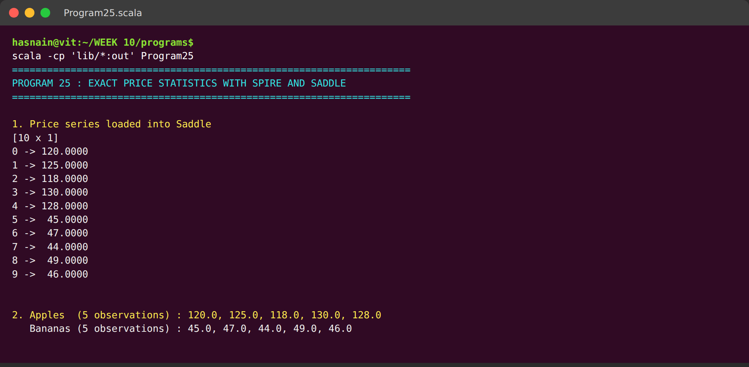  Fig. 4.1: Terminal execution showing the Saddle price series, the apple and banana subsets and the exact Spire statistics.  The ten price readings are printed as one indexed Saddle Series. Row selection then splits them into the five apples and the five bananas, which are echoed back as plain vectors before any arithmetic is applied.
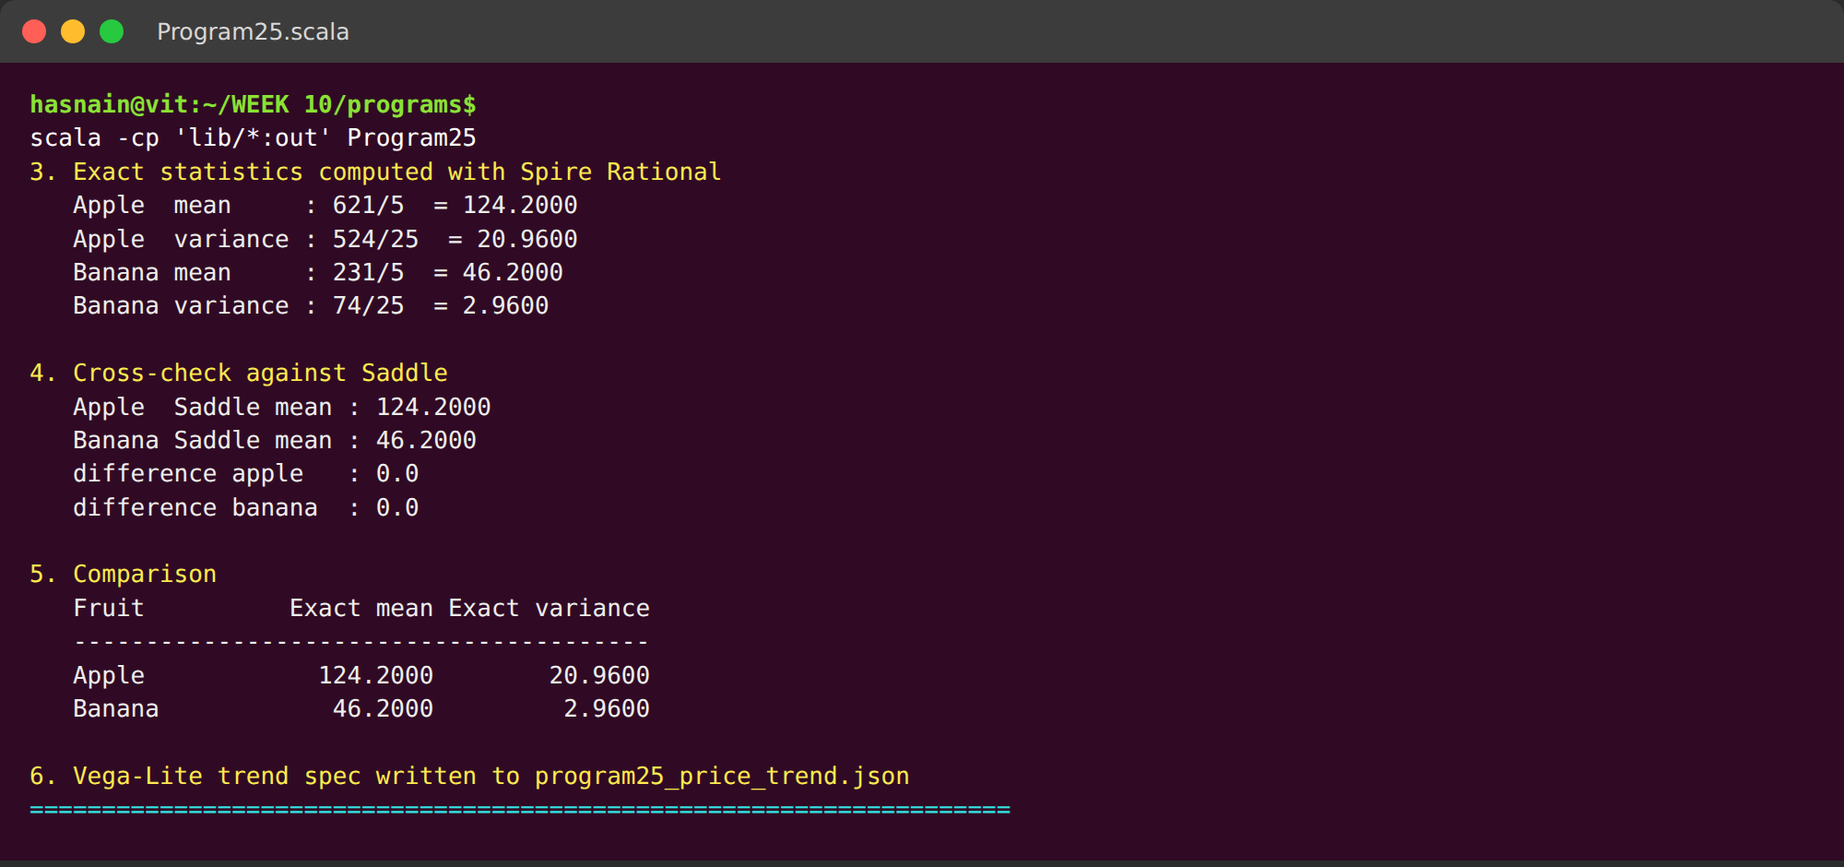
Fig. 4.2: Comparison of the exact and floating-point means, the comparison table and the export of the Vega-Lite trend specification.
Spire Rational returns the mean and variance as exact fractions rather than decimals, and each fraction is printed beside its decimal equivalent. The cross-check section compares those exact means with Saddle's floating-point mean and reports a difference of exactly zero for both fruits, after which the comparison table and the trend export complete the run.
Conclusions | Saddle held the ten labelled price readings and split them into five apples and five bananas. Spire Rational arithmetic produced the exact apple mean 621/5 and variance 524/25, and the exact banana mean 231/5 and variance 74/25. Converted to decimals these are 124.2 with variance 20.96 and 46.2 with variance 2.96, and both matched Saddle's floating-point means with a difference of exactly zero. The price trend was exported as a Vega-Lite specification. The experiment showed that Spire keeps every intermediate value as an exact fraction, so statistics that would normally suffer from rounding drift can be verified against a floating-point library.
References | 1. Spire documentation: https://typelevel.org/spire/  2. Saddle documentation: https://www.scala-saddle.github.io/  3. Class lecture: Spire, Saddle and Vegas in Scala.  4. Python program (GitHub link): https://github.com/hasnainmakada-99/Data-Science-Codes/blob/main/WEEK%2010/programs/Program25_SpireSaddle.scala

